**Report for project part a**

**LP104**

1509853G-I011-0202

Wang, Jingqing

The whole project part a was completed under visual studio 2008. For part a, it totally contains one files.

1. parta.cpp

This file contain the main function.

**Before the compile, please put the measles.txt in the same folder with [project name].vcproj、[project name].aps、parta.cpp files. If you want to change the file path, please add the absolute path of measles.txt into source code.**

**A、Whole idea**

The whole idea of project is using ifstream and ofstream to open or edit the file. In the stream, I mainly use string array and seekg() to find the keyword.

**B、Main function**

1. Firstly, declare two ifstreams and one ofstream.

2. Open the file measles.txt by ifstream. If the file doesn’t exist, the program will exit.

3. Open the result.txt file. If it doesn’t exist, it will creat a result file automaticly.

4. Asking user to input a year and using as the keyword.

5. Searching the keyword in the file measles.txt,and output to the result.txt file.

6. Using another ifstream to check the result.txt file.

**C、Simple output.**

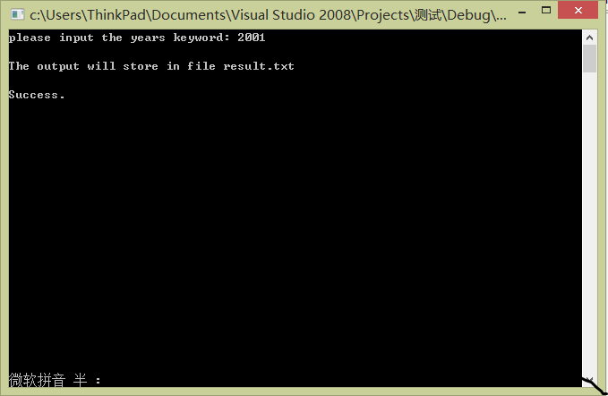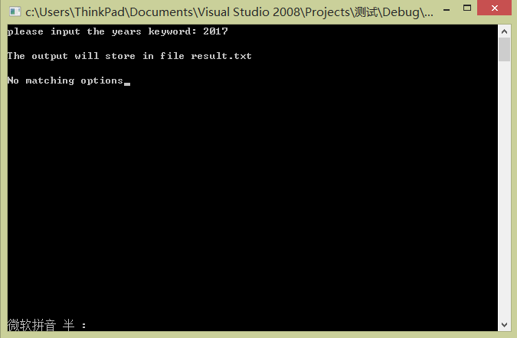

**D、Source code**

#include<iostream>

#include<cstdlib>

#include<string>

#include<fstream>

using namespace std;

int main()

{

ifstream fin,pin;

ofstream fout;

fin.open("./measles.txt");

if(fin.fail())

{

cout<<"Open fail.";

exit(1);

}

fout.open("./result.txt");

if(fout.fail())

{

cout<<"Open fail.";

exit(1);

}

string str0;

cout<<"please input the years keyword: ";

cin>>str0;

cout<<endl<<"The output will store in file result.txt"<<endl<<endl;

string str1[10000];

int i,n;

n=str0.length();

for(i=0;fin.peek() != EOF;i++)

{

getline(fin,str1[i]);

if(str1[i].substr(88,n) == str0)

{

fout<<str1[i]<<endl;}

else if(str0==""||str0=="all"||str0=="ALL")

{

fout<<str1[i]<<endl;}

}

pin.open("./result.txt");

if(pin.fail())

{

cout<<"Open fail.";

}

if(pin.get()==EOF)

cout<<"No matching options";

else

cout<<"Success.";

pin.close();

fin.close();

fout.close();

return 0;

}